Enrolment Information For International Students

Letter from the Principal

Welcome to Hamilton East School. Our school is a signatory to the New Zealand Code of Practice of International Students, as established under section 238F of the Education Act 1989. This means we meet the quality standards of pastoral care as set out in the Code of Practice

We welcome international students to our school and look forward to providing an enriching educational and cultural experience for them.

In this document you will find all the information needed to apply for enrolment at our school. Please do not hesitate to contact us for further information office@hameast.school.nz

We welcome visitors to our school. You can arrange a visit prior to enrolment, or alternatively at the time of enrolment your family will be offered a tour of the school, by myself and/or the Leadership Team, Trace May, Lynda McKenzie & Natalie Sullivan. This is a time that you can see the facilities, meet with school leaders, your child’s classroom teacher and support staff, and ask any questions.

For the first few weeks your child will be “buddied” with a classmate to help with settling into the class and school.

Your child’s class teacher and the Leadership Team will always be available to answer any queries or concerns during your child’s stay with us.

You can find out more about us through our website www.hameast.school.nz

Pippa Wright
Principal
Hamilton East School

Costs

Hamilton East School is a state school. All New Zealand children enrolled into a state school are entitled to a free education. International students do not qualify for this, and are required to pay a fee.

Fees: The fee of $3,500 per term is set by the Hamilton East School Board and pays for:
- A portion of the cost of employing teaching staff.
- A portion of the cost of employing a Learning Assistant, who will support your child’s English Language Learning programme.
- Tuition by a trained classroom teacher from 9:00 to 3:00, Monday to Friday.
- A portion of the school’s operating costs.
- Administration costs.
- Your child’s stationery.
- The cost of trips and events happening in school time.
- Additional charges made by the ministry and government, such as GST and costs for being a signatory to the Code of Practice for the Pastoral Care of International Students.

Fee Protection: All money received from International Students is coded and banked immediately into the school’s bank account. A reserve is always available to provide refunds if they are needed.

Refunds: Refunds will be given following our refund school procedures, which can be viewed on our website.
- Applications are made in writing to the Principal
- The Principal will make a decision on the amount to be refunded, based on the costs already accrued, and an administration fee of $150.
- No refund will be made if a student withdraws during the second half of their course.

Schooling in New Zealand and Enrolment

Students can choose to be enrolled in a state primary school, from their fifth birthday. This is Year 1. Students stay at Hamilton East School until the age of 10 or 11 (depending on their birth date). Then they move to Intermediate School, and around the age of 13 on to Secondary School. Students move from one year-group level to the next at the beginning of each school year.
Assessments are reported to parents at least twice a year. There is no formal certificate of achievement until secondary school at Year 11, when national exams occur.

Conditions of enrolment at Hamilton East School
To be considered for enrolment:
- The family must be living in the Hamilton East School zone at the time of final enrolment. See page 5 for a picture of our Hamilton East School Zone Map. You can also find details of this on our website. www.hameast.school.nz
- Students must be enrolled by parents or legal guardians. We do not work with agents.
- Students must live with their parents or legal guardians for the entire time of enrolment. If living with a legal guardian, legal proof of guardianship must be supplied. The school will meet with the parents/guardians once a term, to establish that this living arrangement is continuous. If the student does not remain with the parent or guardian, they will be contacted and if this can't be remedied or enrolment contract is void, Immigration New Zealand will be notified and the visa would be revoked.
- Students must have the necessary student visa or permit for the duration of the enrolment. It is illegal to be enrolled in a New Zealand school without this. www.immigration.govt.nz
- The student and at least one parent must have full health and travel insurance for the duration of the enrolment. This includes: travel to and from New Zealand from the date of departure; travel within New Zealand; medical care in New Zealand- including diagnosis, prescription, surgery, hospitalisation and any associated costs.

Enrolment Procedure
- Read the international enrolment information pack online before you request to enrol.
- Once you meet the requirements outlined in the information pack, email the Principal or the school office with your proof of address showing you live in the Hamilton East School Zone, we need to know that you live within our zone before we progress further, alongside this will be your request to enrol. You can email principal@hameast.school.nz or office@hameast.school.nz
- You will be sent an Enrolment Application Pack.
- Fill in a student enrolment application, which provides us with information about your child and your family. Email this along with copies of passports, birth certificates, immunization certificates to office@hameast.school.nz
- We will then send you an “offer of place” letter, which will be subject to you having the necessary visa, insurance and accommodation in the zone. Use this for your “visa in principle” application.
- Once you have this “Visa Approval in Principle” email this to us, along with your insurance documentation and deposit of fees into our school account.
- We will send you a renewed offer of place, along with your receipt. You will use the renewed offer of a place to confirm your visa with immigration. Once immigration has confirmed your visa completely, let us know.
- You are welcome to come to the office and meet the Office Administrator who has been communicating with you. This is a good time to ask any further questions.
- At this time, make an appointment to meet our Principal and Leadership Teaml. They will give you a tour of the school when you can meet teachers, staff and discuss anything further.
- If any details of enrolment change during your child's stay at our school, it is your responsibility to notify the school office of these changes.

Immigration Matters

Immigration Services will be informed when:
- The student has completed the course that they have been enrolled in and has returned home.
- The student has left Hamilton East School to continue at another New Zealand school.
- The student fails to attend school on a regular basis.
- Visas have expired.
- Tuition is terminated for any reason- as stated below.

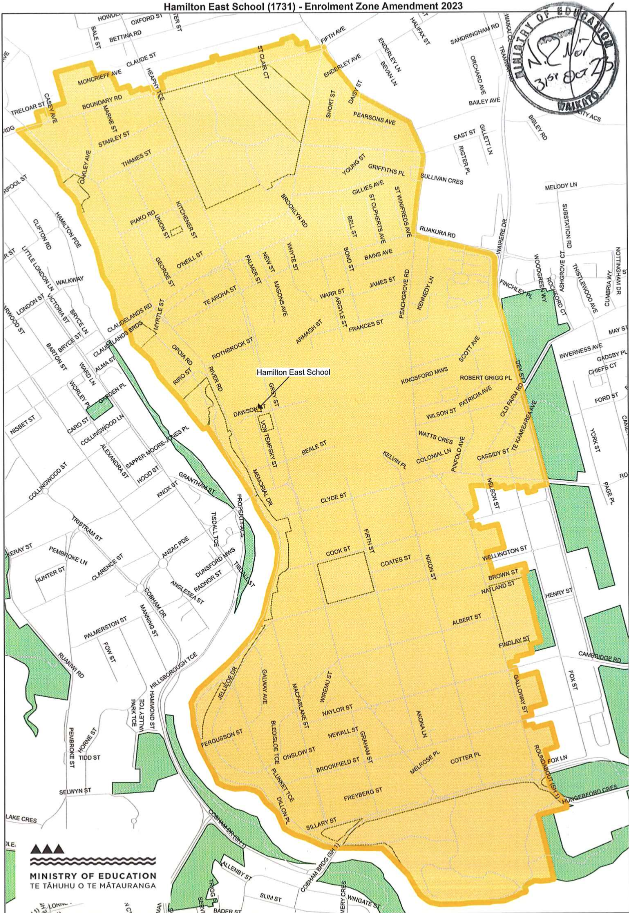
Hamilton East School Zone:

When things go wrong
Termination of Tuition
Tuition may be terminated in the following circumstances:
- Gross misconduct, if resolution has not been able to be achieved
- Breach of visa, accommodation, insurance requirements and enrolment agreements.
- The inability of the school to meet the child’s needs, NZQA or ministry requirements.
- Continual non-attendance that is not able to be resolved.
- See procedures on our website for: Attendance; Grievance; Discipline

Student Behaviour/ Disciplinary Action
Our school Behaviour Plan states our processes in response to all students' behaviour. This includes international students.

Most behaviour is responded to within class and the school day, and is considered to be part of a child’s social learning. Classrooms develop a Class Treaty at the beginning of the year. This, and the school toolkit highlight expected behaviours. Response to minor incidents is usually focused around developing positive relationships and social skills. Sometimes consequences may involve loss of certain privileges.

The principal will be involved in any serious conduct or behaviours of a student such as: assault, repeated harassment, sexual or racial verbal abuse, repeated serious misconduct.

In this situation the Principal will meet with the parent/legal guardian with the aim of resolution.
The principal may take further disciplinary action if it is considered that:
(a) the student’s gross misconduct or continual disobedience is a harmful or dangerous example to other students at the school;
(b) because of the student’s conduct or behaviour, it is likely that the student, or other students at the school, will be seriously harmed if the student is not stood-down or suspended or excluded as the case may require;
(c) the student’s conduct or behaviour is in breach of the school rules or this contract of enrolment, and one or more of the following applies:
(i) the breach or breaches would constitute an ongoing risk to the student’s education, health, safety, well-being or personal welfare for which the school is responsible under the Education (Pastoral Care of International Students) Code of Practice 2016;
(ii) the breach or breaches would constitute an ongoing risk to another person’s education, health, safety, well-being or personal welfare.

In this situation the principal may either stand down or suspend the student. These are serious measures which involve the Board.
Stand down means a student is not allowed to attend school for the stipulated number of days. If parents require a further meeting at this time, this will be arranged.
Suspension is a more serious action. This means a student will not be allowed to attend for the period of suspension, which can be up to a week long. Over this time meetings will be held with the parents and the Board. The result of these can be reinstatement to the school programme or exclusion. Exclusion means the student would no longer be able to attend Hamilton East School and will result in 20 days notice of termination of the contract of enrolment. More details are available for you about this on our website.

If you have a concern or complaint: Disputes Resolution Scheme
For minor concerns that are to do with the classroom, contact the classroom teacher. If they are about enrolment matters contact the office. If you need support with this the Leadership Team is always available.

For any other concerns, contact the Leadership Team or the Principal. We will work with you to resolve any issues to the best of our ability.

If your concern is not resolved after going through the school processes contact NZQA Complaints or ring 0800697296. Another contact for any contractual or financial complaints is www.istudent.org.nz
These supports are available at no cost.

Hamilton East School Curriculum

Learning at Hamilton East School follows the New Zealand Curriculum
You can find out more about what this looks like at Hamilton East School by looking at our school website www.hameast.school.nz. Here you will also find our latest Educational Review Office report. The Educational Review Office is an independent body, contracted by the Ministry of Education to evaluate and report on the performance of all schools in New Zealand. The school charter is also on the school website. This will inform you more deeply about our school, our vision and goals.

Our school vision and whakataukī for our students is to “ Stand Tall and Reach High” “Tū Tangata Tū Māia”. This means be proud of ourselves, each other and our school- have confidence now and into the future.
Our guiding principles are for Hamilton East School learners to be: Engaged, Respectful, Literate, Curious and Connected.
The toolkit details our guiding principles in children’s language. It is based on the key competencies of: Participating and Contributing; Relating To Others; Using Languages; Managing Self; Learning to Think. You will see the toolkit in every classroom. Teachers and students refer to it often.

Our school treasures our bi-culture heritage. We celebrate and embed Māori culture and language throughout our learning day. We also embrace the many cultures our migrant students bring to Hamilton East School, further enriching our learning experiences. We respect all ethnicities and learn from each other.

Other special features of our learning at Hamilton East School include: Environmental education with students learning about, within and for the environment; Digital platforms of learning in all classrooms; Full participation in a variety of social, arts and sporting activities.

Classroom Learning: At Hamilton East School your child will enjoy the experience of learning alongside New Zealand students in an English-speaking classroom. He/she will be a full member of a regular classroom programme, as indicated below.

We have 21 classrooms. Their organisation is based on students’ ages and their academic, social and emotional needs. Usually there is one teacher for each class. Individual class sizes can range from 10 students (for the younger students) to 35 students for the older students. Changes of classes can be made during the year, but usually we try to keep students in the same class all year.

The day is divided into 3 classroom learning times, allowing time for 2 breaks for eating and free play.

Learning formats and venues vary, occurring in the classroom, playground and the community around us. Classes in teams can work together, joining as large groups and sharing the teachers. This allows for a wider range of activities being offered to better meet the needs, developing collaboration and giving students greater opportunity to follow learning pathways that they have an interest in.

Classrooms are organized so children can easily access the learning materials that they may require for learning. This happens in directed ways during instruction and more freely during independent activities.

The teacher has the responsibility to maintain a safe, effective, learning environment that is fun, relevant, creative and stimulating. Specific learning opportunities are planned by the teachers and designed to meet the student's individual needs. You will see students working in individual, paired, social and academic groups and whole class activities.

Teachers work in partnership with students and parents, to respond to needs, encouraging students to be involved in their own learning pathways, to voice their opinions and identify their next learning steps. You will see evidence of this in every classroom.

Teachers assess students in a variety of ways and base teaching/learning programmes on a range of evidence of their current needs.

We strive to develop the whole child: socially, emotionally, physically and intellectually. The whole school works together to achieve this.

English Language Learning Needs
Every classroom in Hamilton East School has students who are learning English as a second language. Programmes are organised to enable students with limited English-speaking ability to participate in the same programmes as their peers. Your child will be supported by: content and delivery that is adapted to their English level; Learning Assistant support; a variety of English Language learning resources, including digital; a programme that is monitored and lead by the Associate Principals.

As soon as your child starts school at Hamilton East, he/she will be buddied up with a “friend” who will support him/her to settle into the school. Sometimes this will include a child who shares ability with the same language, or from the same home country.

The Associate Principals will meet with your child, within the first 2 weeks of starting with us, to assess his/her language ability. It is their responsibility to ensure appropriate English Language Learning support is given to meet your child’s needs. Usually this is in the form of English oral language programmes that are delivered by the Learning Assistant, organised and monitored by the Leadership Team. We try to ensure programmes occur within the student’s own classroom environment. We believe students learn best when interacting with their peers in a range of situations, including play, so it is important that any withdrawal from that environment is kept to a minimum.

Special Education Learning Needs
As an international student, your child cannot access free educational support for special needs, as is offered to New Zealand students. Your fees do not cover the cost of this. However, wherever possible, the Leadership Team with responsibility for Special Educational Needs in the school, will support you and your child to access any wider services that may be available to you. They will ensure that your child has every support possible within the classroom, so his/her special needs are understood and responded to.

Attendance

Classroom learning starts at 9:00, and continues until 3:00 Monday to Friday. There are 4 terms, separated by three 2 week holiday breaks and a 6 week break in December and January. Holiday dates are listed on the school website.

Attendance and lateness are monitored. During school weeks, full attendance is expected, unless your child is too unwell to attend. It is preferable for your child to be at school between 8:30 and 8:45.
If your child is going to be absent, you will need to ring the school office 07 8393377 or text 021 289 9811 to explain the reason for your child’s absence. This is a schoolwide expectation. If absences are not explained, the office and/or the Leadership Team will contact you. If continuous absence occurs without explanation, the child’s tuition could be terminated and immigration informed.

Important Contacts
Pippa Wright - Principal

Pippa Wright is the Principal of Hamilton East School, with oversight of the needs of all students. She will take a personal interest in the enrolment of your child and your child’s progress and happiness at Hamilton East School Email: principal@hameast.school.nz

Hamilton East School Office

The office is responsible for the administrative details of enrolment into our school. This includes checking eligibility criteria, enrolment forms, passport and visa details. The office communicates with you and supports you throughout the enrolment stages.

Email: office@hameast.school.nz

